**PROFESSIONAL ENGINEER**

**CAREER EPISODE 1**

**Written by IGBINOBA MAXWELL OCTOBER 2019**

**1.1 Introduction**

Chronology: June 2004 - November 2004

Location: Minna, Niger State, Nigeria.

Organization: Federal University of Technology Minna.

Title: Design and Construction of Automatic Streetlight Control Panel.

As a final year student of electrical/computer engineering, it was compulsory to do a project as a prerequisite for graduation. And also mandated to defend it relatively to the engineering field which I am studying. The topic of the project was the “DESIGN AND CONSTRUCTION OF AUTOMATIC LIGHT CONTROL PANEL," using electronic devices. The whole project involved both design and construction.

**1.2**  **Background**

Streetlight is a basic requirement in today’s time. The movement of vehicle and people during night, cold and cloudy weather is made easy by the streetlight system. Automatic streetlight system is created to reduce the time and effort spent on the manual switching of the lights. The intensity of light is taken as the basis for the automatic control of the streetlight. During the day, when the intensity of light is higher, the light is turned off and when the intensity of light is lower at night of any dark condition, the light is turned on. This saves time as well as preserves energy.

As a prerequisite for completion of my Bachelor of Engineering program in electrical engineering, I was to undertake a project to design and construct an automatic light control panel. Before I started the project, I had to come up with some criteria, which included:

(a) Necessity for the project.

(b) Design of the panel

(c) Functionality

(d) Serviceability

(e) Aesthetics

(f) Acceptability of the end-user and

(g) Compatibility to the existing electrical network Infrastructure

I constructed the panel to be durable and to be able to withstand weather, heat, and short-circuiting.

In designing a modern lighting system, particular attention has to be paid to the distribution of light from the source.

Also, the relation of the lamp's brightness to the dark background against which is generally seen at night and the weather resistance of the light coupled with the ease of maintenance.

When designing the control panel, I made sure the rating of lamps to be supplied was known, and the total power to be delivered to each light on the lighting network was also known.

In this project, a simple control mechanism for the automatic switching of the streetlight was designed, developed and tested for the conservation of energy and elimination of human dependency. The circuit was designed in different functioning stages. An LDR was used for generating the output as per the intensity of incident light. The circuit made use of the flip-flop, comparator as well as oscillator for providing accurate switching signal to the relay.

**1.3** The main objective of the project was the need to conserve power during the day when the streetlight is left ON without switching OFF by the manual operator and the need to provide clear visibility for traffic and pedestrians at night or cloudy weather. In previous designs of control panels by engineers, the board consisted of circuit breakers with bypass fuses, a timer, a contractor, and some miniature circuit breakers. But in this design, electronic components were used, which included the light-dependent resistors (LDR), the comparator (OP-AMP), the 555 timer, D flip-flop, some transistors, and diodes. The relay was used to directly switch from the electronic part to the electrical contractor, which directly supplies the lamps. The other aims were:

* To provide visibility to the users during night and cold weather.
* To remove the need for manual effort for switching the light.
* To conserve energy with efficient control of the streetlight.

I designed this panel to operate effectively when there is a change in the intensity of light. When light falls on the light-dependent resistor (during the day), the non-inverting pin of the IC goes low below the reference inverting pin and hence gives a low output to the supply. Therefore, the transistor was switched off in this mode, and there was no supply to the load.

**1.3 Duties**

The basics I followed in the design of the panel involves

* Designing the power stage
* Design of the comparator
* Design of the flip-flop
* The switching designs
* Load analysis
* Oscillator stage

**Personal Engineering Activity**

**1.4** In the first part of the project after the selection, I carried out the literature review on the selected project. I took reference from various works of literature for understanding the clear idea behind the automatic streetlight control. Also, I learned about the electrical and electronic requirements for the project. I studied the basic working of the streetlight and understood the control mechanism through different ways. I also learned about the component requirements of the project which included LDR, relays, contactors, etc. I researched about the comparator, flip-flop and different terminologies related to the project. During the literature survey, I assessed various previous works done in the similar topic and took knowledge from them regarding the control panel of the streetlight for its automatic control.

**1.5** Then, I chose the components necessary in the design of the control panel. Firstly, I selected LDR for providing the output as per the intensity of the light in the surrounding. I decided to use 555 timer as the oscillator. I chose relay for the control of the contractor which was selected for directly supplying the lamp. For the comparator, I decided to use an operational amplifier IC LM393. I also used switching transistors BC546 for switching the relays in the circuit. For the power supply stage of the project, I chose an arrangement of the step-down transformer, full-wave bridge rectifier with diodes, a filter capacitor and two voltage regulators for providing a voltage of 5V and 12V to the required circuit. After that, I worked on a generalized block diagram of the process to be followed in the project. I defined different stages and section of the project and interconnected them to develop a simplified block model. I established the connection between the comparator and flip-flop stage which compared and proceeded further for the switching of light which was represented by load block.

Switching

Comparator

Flip-flop stage

Load

Oscillator stage

Power stage

*Fig: Block diagram*

**1.6** For the comparison of two voltage source, I designed a comparator circuit. This circuit compared the magnitude of voltage provided information on their magnitude weather theirs magnitude were equal or not. The comparator stage in the circuit was used to sense when light falls or not on the LDR. In this stage, I used an op-amp for comparing the values of intensity of light which were sensed by LDR. The principle I used was when the light intensity drop (at night); the energy across the LDR increased above the reference voltage. Also, when the intensity increased (during the day), the voltage across LDR reduces below the reference voltage. The reference voltage of 3.0V is at the inverting input of the comparator. The changes in the voltage level give an output of either HIGH or LOW, which satisfied the reset data condition of the flip-flop. I worked on the flip-flop stage of the panel. In the flip-flop stage, I used D flip-flop in order to start and stop the lighting process based on its set and reset conditions. I used the logic circuit such that the output of the flip-flop was low when there was no input to the flip-flop and high when there was input. I designed the required circuit in Proteus Software.

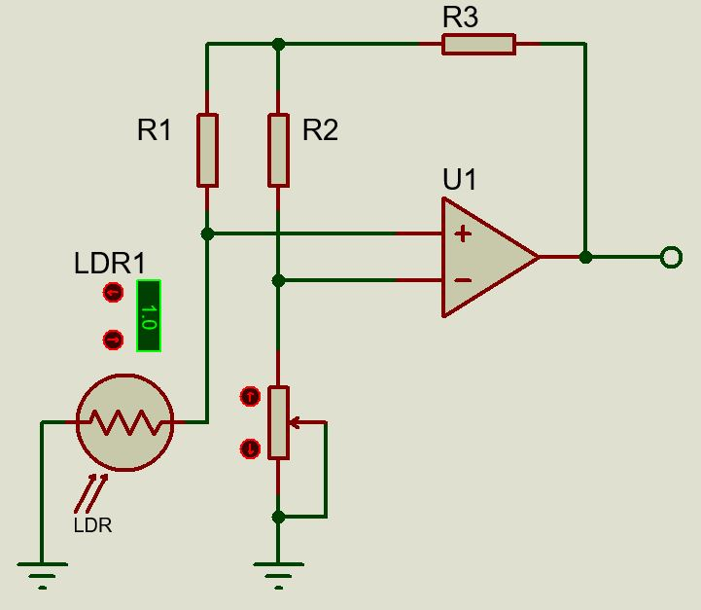

*Fig: Comparator circuit*

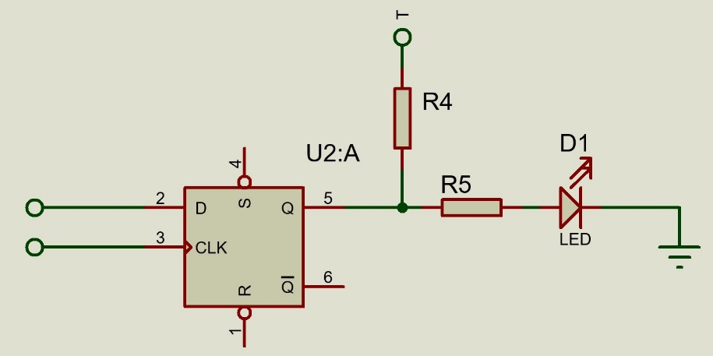

*Fig: D-flip flop*

The flip-flop stage I designed to tell the system when to start and stop the lighting process. The system operation can be explained with truth table as below.

|  |  |  |  |  |  |
| --- | --- | --- | --- | --- | --- |
| MODE | D INPUT | CK | Q | Q” | R |
| SET | 1 | $$↑$$ | 1 | 0 | 1 |
| RESET | 0 | $$↑$$ | 0 | 1 | 1 |
| HOLD | X | X | 0 | 1 | 0 |

X----Don’t care

$↑$----Rising stage

Q AND Q”------- Output

D------ Data input

The logic control circuit operates in its set and resets mode. If there is no input to the flip-flop, the Q output will be low. If there is an input, the Q output switches the relay.

**1.7** In this next part, I designed the oscillator stage where I used a 555 timer as an astable oscillator stage with 1kHz frequency. I used the equation for the astable timer frequency and determined the values of resistances required in the oscillator circuit. I used a capacitance of 100nF and determined the resistances of 1k and 6.8k. I also designed the switching stage in which I designed a switching transistor which was used for switching the relay based on the flip-flop output. I used a base resistor for the perfect switching of transistor in saturation. I also used a resistance of 400 ohms for the protection against the back emf from the relay, which was an inductive load. I also did the designing of switching transistor stage with flip-flop which helped to switch the relay circuit and turn ON the lamps. This operation was executed when the output from D flip-flop was high and the lamp would turn OFF when the D flip-flop output was low.

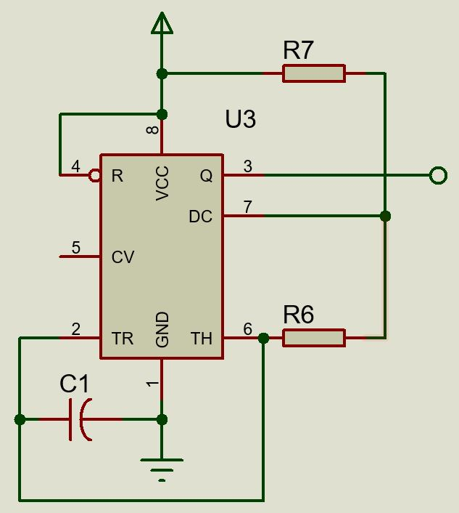

*Fig: Astable clock stage*

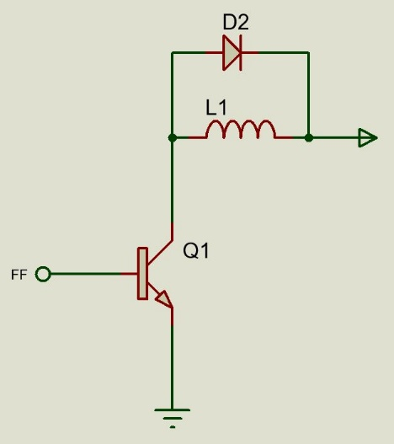

*Fig: switching transistor*

I designed the switching transistor (TR1) to switch the relay, which powers the bulb. The switching transistor operated in class A mode. I used a base resistor for ensuring the accurate switching of transistor during saturation. Similarly I also connected R5 diode which protected the transistor against back EMF which could be generated due to relay coil which acted as inductive coil.

**1.8** I designed the power supply stage to be a linear supply type, and which included step-down transformer, a filter capacitor, and a two-voltage regulator to give the 5V and 12V required voltage. I firstly used a step-down transformer to get a lower value of ac voltage from the mains supply. Then, I employed a full wave bridge rectifier which was used for the conversion of ac to dc which was required by the circuit. Following that, I added capacitor filter and voltage regulator to the circuit design.A rectifier was designed with four diodes to form a full-wave bridge network which works with the capacitor to give the desired output.

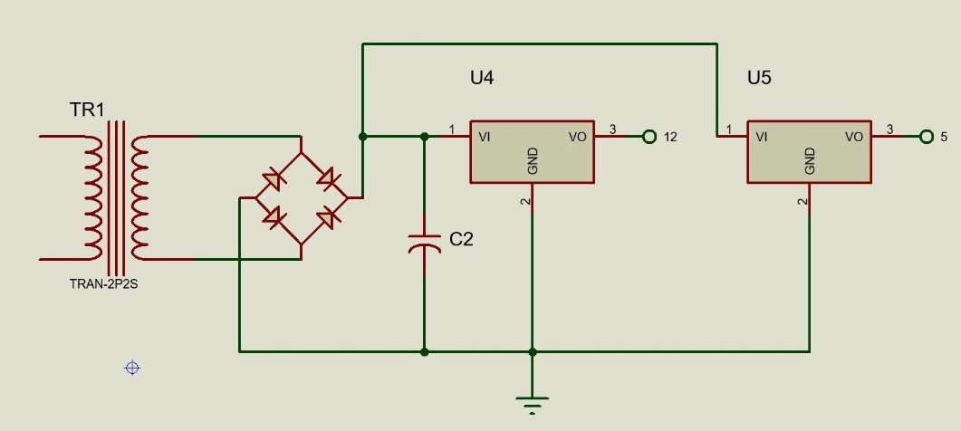

*Fig: power supply circuit*

**1.9** After design of separate circuit, I then proceeded towards designing of overall circuit. I used previously designed circuit and connected them accordingly. I placed 5 lamps whose operation were controlled through relay.

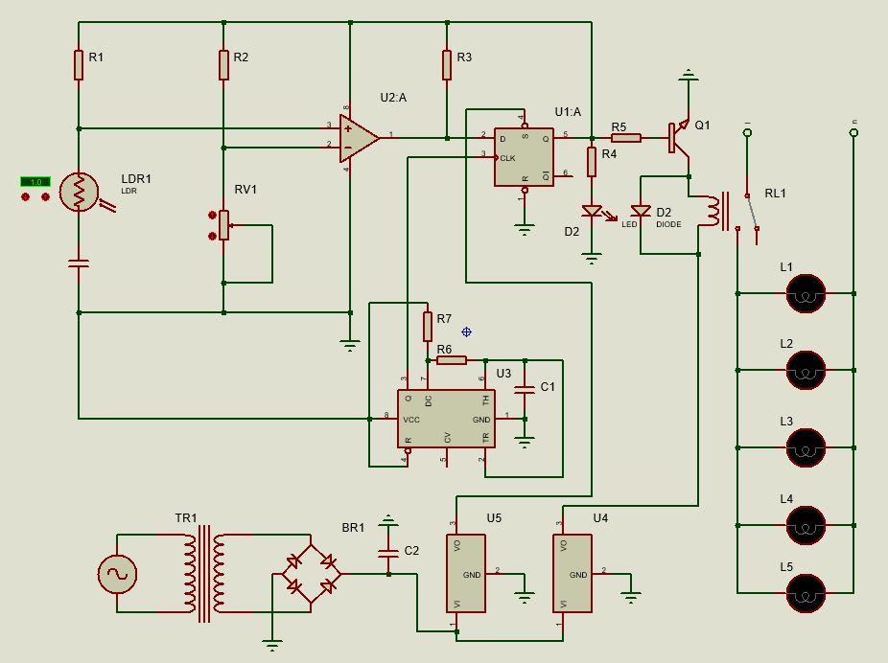

*Fig: Overall circuit design*

**2.0 SUMMARY**

The project was purely for academic purposes, but it can be used in an institution, factories, and commercial purposes where external lights are used to prevent an accident at night and provide security by illuminating the streets and pavement at night. The design was completed with its feasibility from different aspect like economy, availability of components, ease of maintenance, and research materials. The design performance had to meet the specifications. The operation and performance of this system is dependent on the user who is prone to human error, such as wrongly positioning of the sensor or poor calibration of the sensor.

I made a recommendation that the design should be interfaced with the computer to enable the ability to increase variables of the coding systems and decrease the chances of breaking the codes. And also, the department of electrical/computer engineering should able to do more research on the availability of other components by involving more hands.